Kaeden Samsunder
XHAW5112
ST10313111
Milestone 1

Report of clients requirements for their website and mobile app
Users must be able to use either platform and still be able to navigate them smoothly and comfortably. The website and mobile app must include a home page, summary of six-month courses page, summary of six-week courses page, details of each six-month course on separate pages, details of each six-week courses on separate pages, a web page where users when applying for a course or multiple courses can calculate the total cost of their purchases and lastly a web page with the clients company’s contact details.

Home page
Must have a logo at the top left of the screen. A brief description on what the company does for the community. Must have pictures that represents the growth of the company. Links to the six-month summaries and six-week summaries.

About page
Must have logo at the top left screen. Description of the company’s past and growth from there is present with pictures of the founder and small workforce.

Six-month Courses page & Six-week Courses page
Must have logo at the top left of the screen. The six-month page must have a list of the six-month courses with each course linked to their respective summary page via using a hyperlink. When you click on the courses name it should take you to the summary of that course. The six-week page must have a list of the six-week courses with each course linked to their respective summary page via using a hyperlink. When you click on the courses name it should take you to the summary of that course.

Get involved page
Must have logo at the top left of the screen. A customer-oriented form that asks for contact information such as name, phone number, and email. This form is accompanied by a checkbox list of available courses. Customers have the choice to choose one or multiple courses. Each course entry should display its associated fees. Upon completion, the customer can submit the form to request a consultant to contact them for course bookings. The selected courses are stored in an array to generate an invoice inclusive of applied discounts. A calculator button is present on both the web page and mobile app. When clicked, it reveals the total fee, accounting for discounts and a 15% VAT. It’s important to note that the displayed fee is a quoted amount and not a formal invoice.

Contact page
The company’s contact information needs to have the phone number, email address, and physical addresses for the three venues in Johannesburg. It might be a good idea to add a map for each venue to help clients find them easily. On both the mobile app and the web page, there should be a drop-down menu. Also, it’s important to make sure that the data entered in various fields/screens is correct. This includes handling errors to ensure that the right types of information are entered.

Website wireframes:
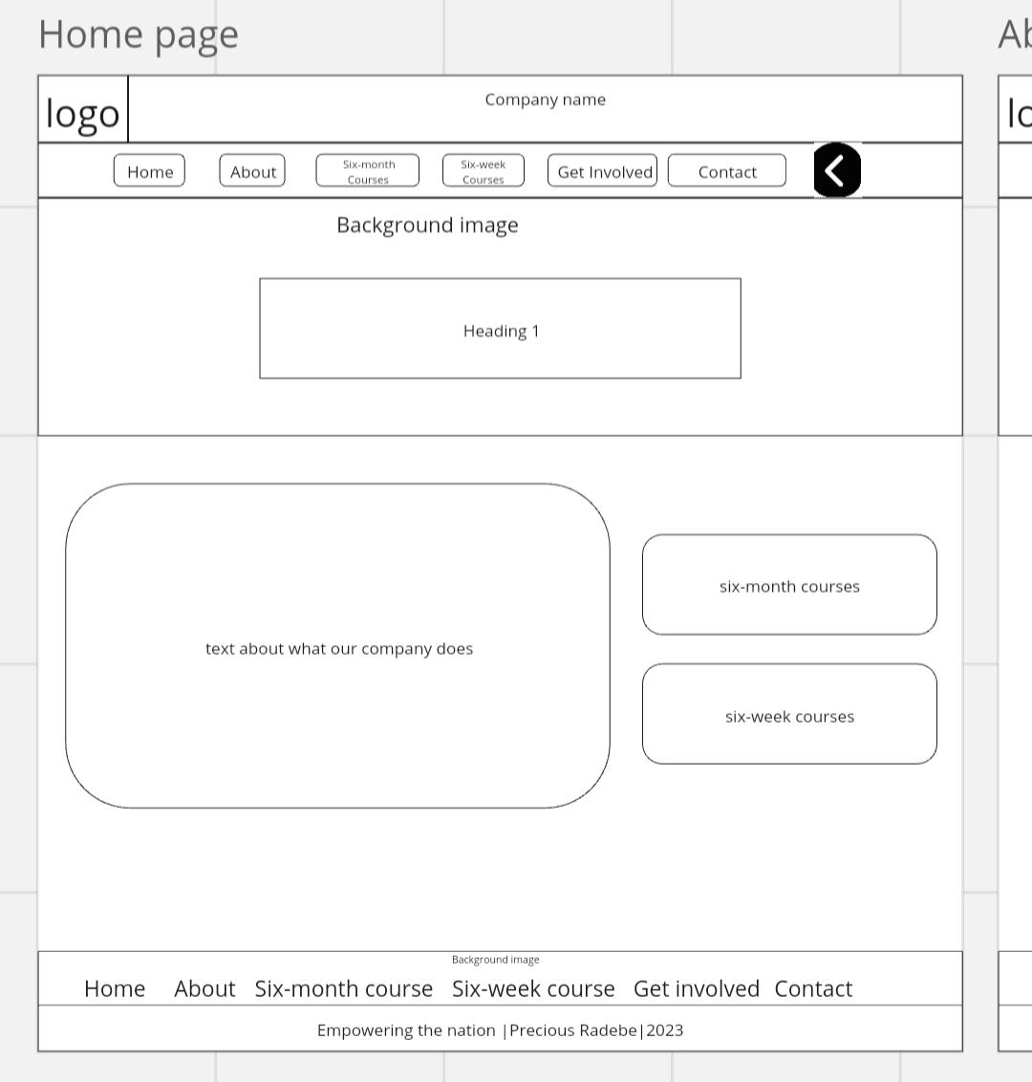

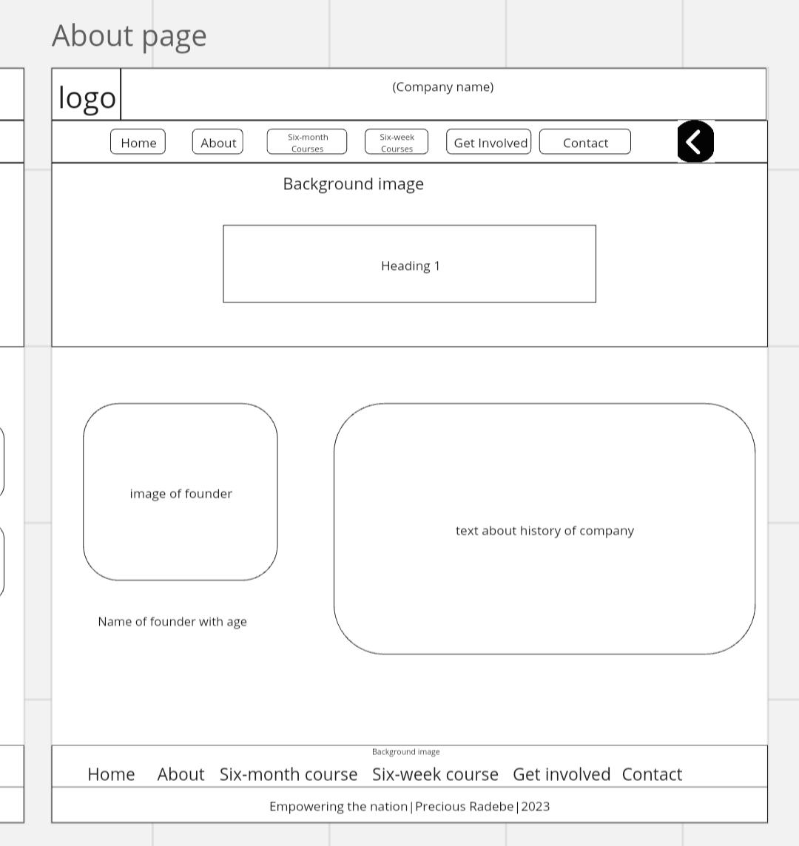
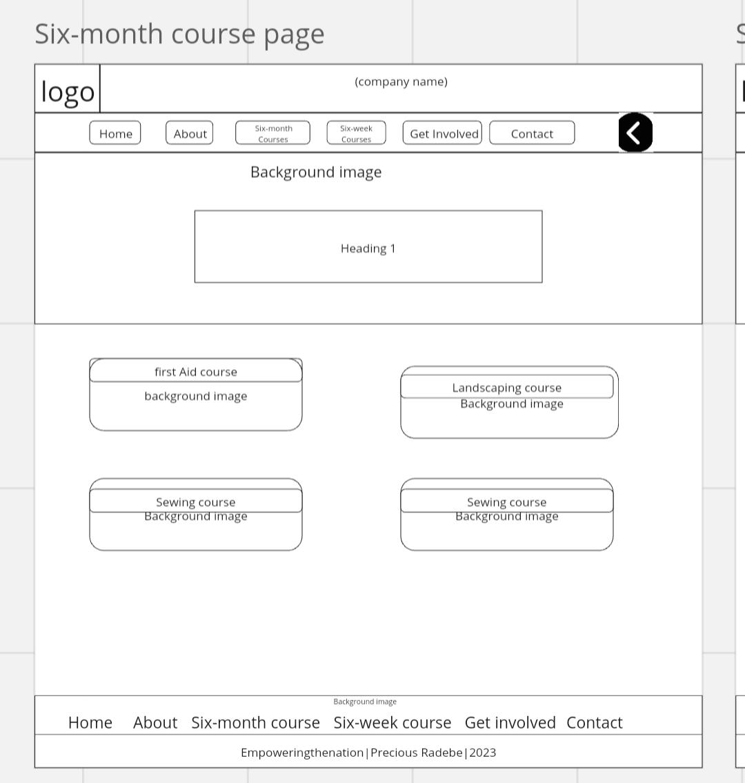

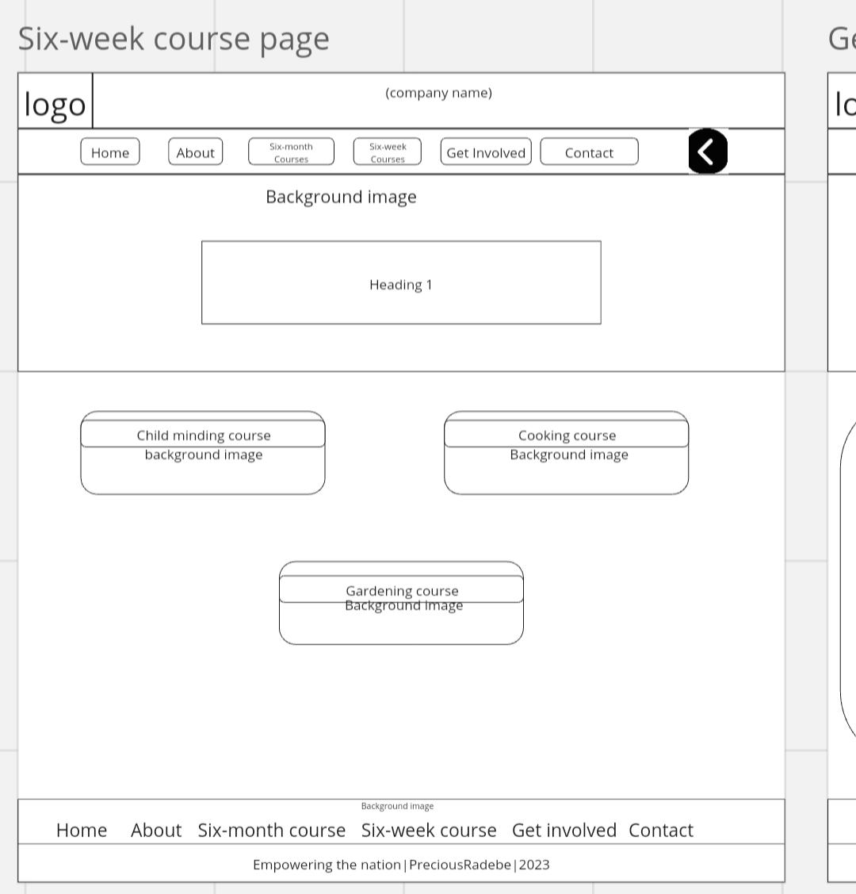
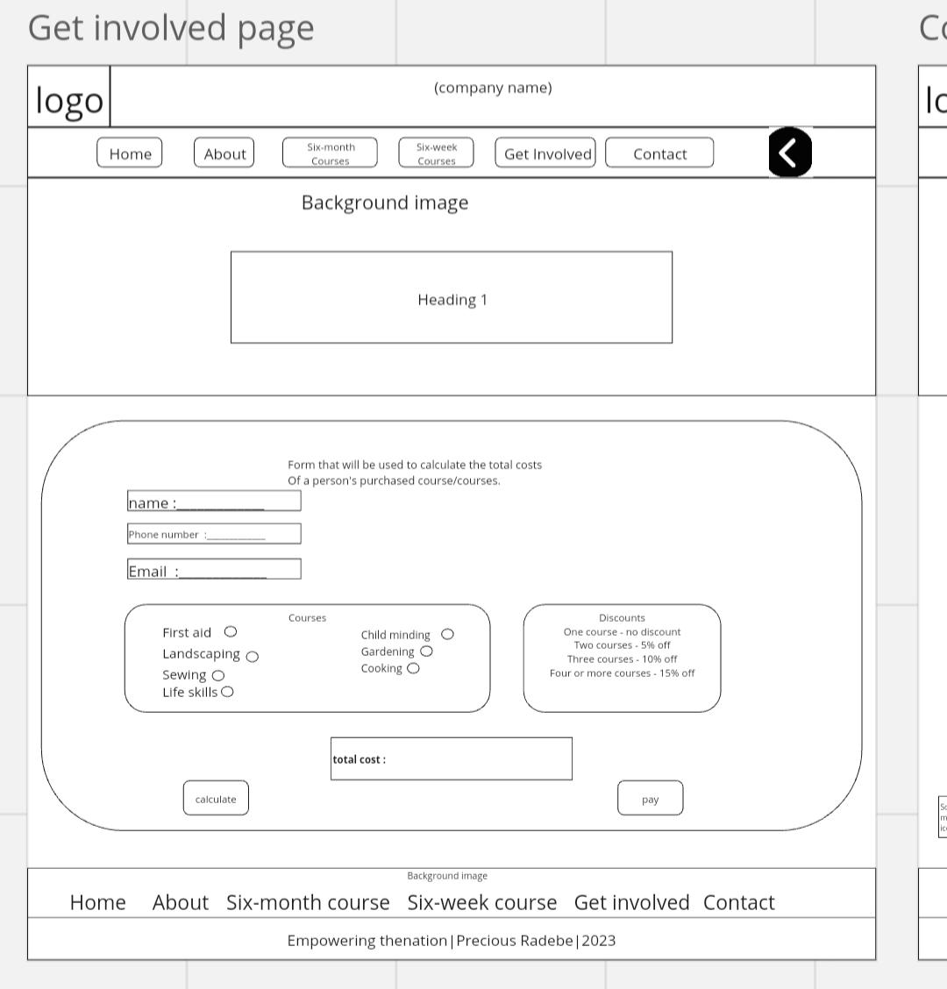
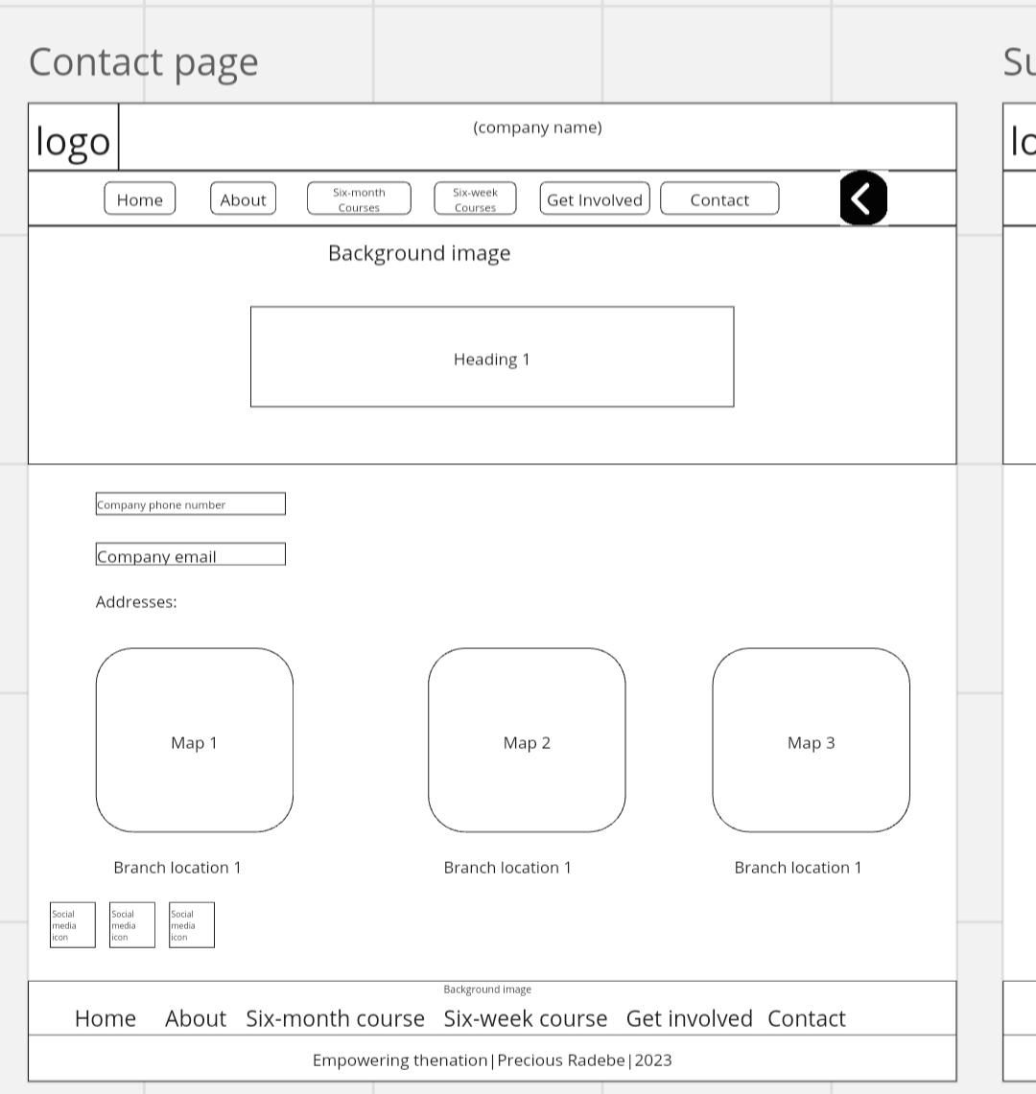

Mobile app wireframes:
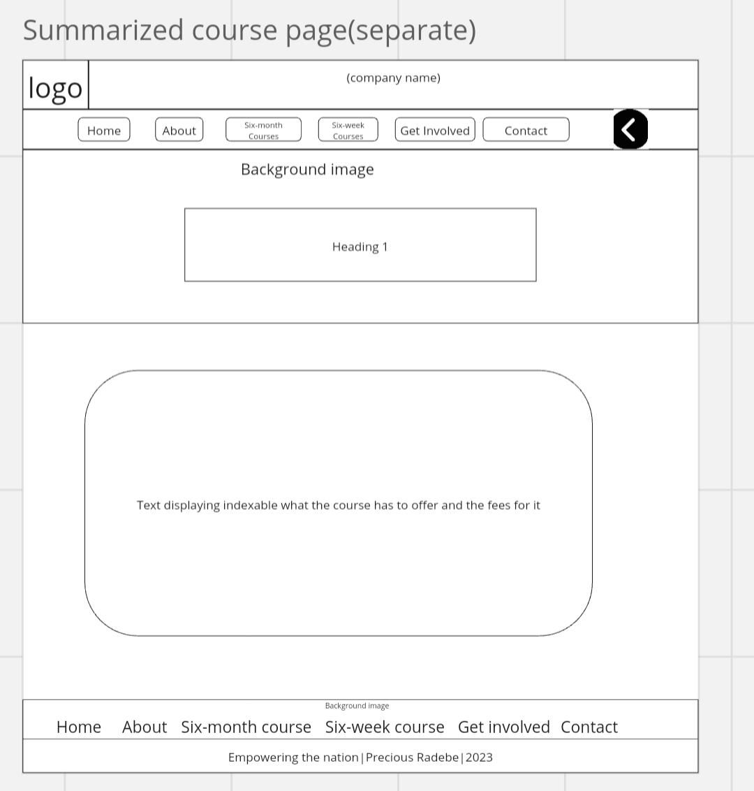

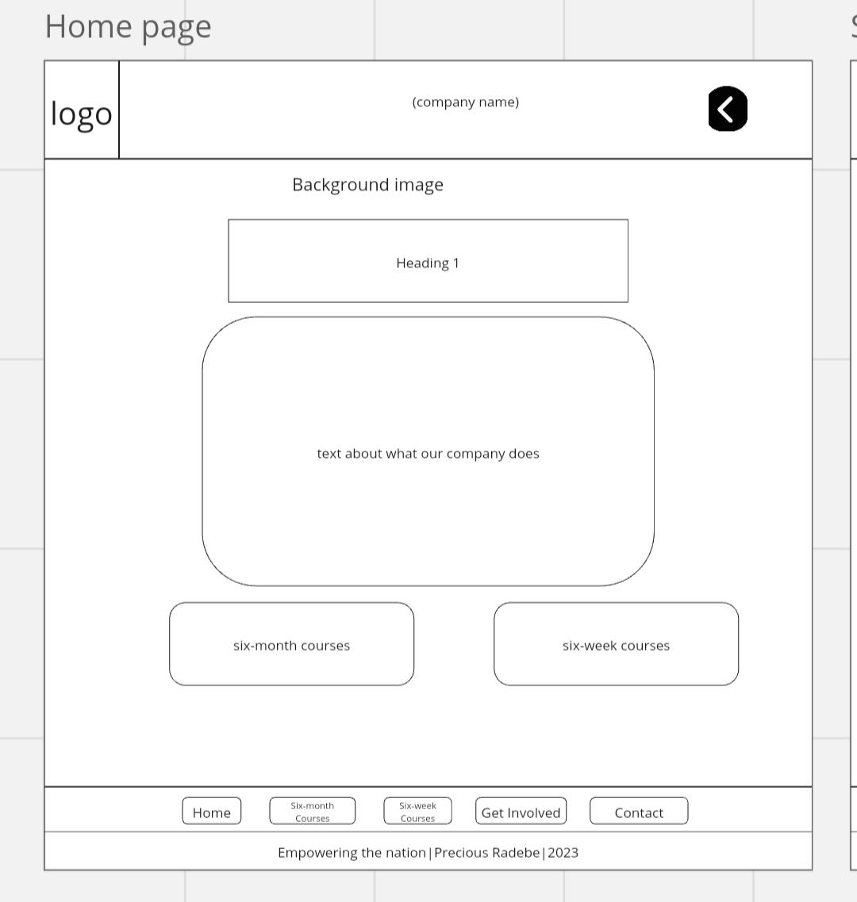

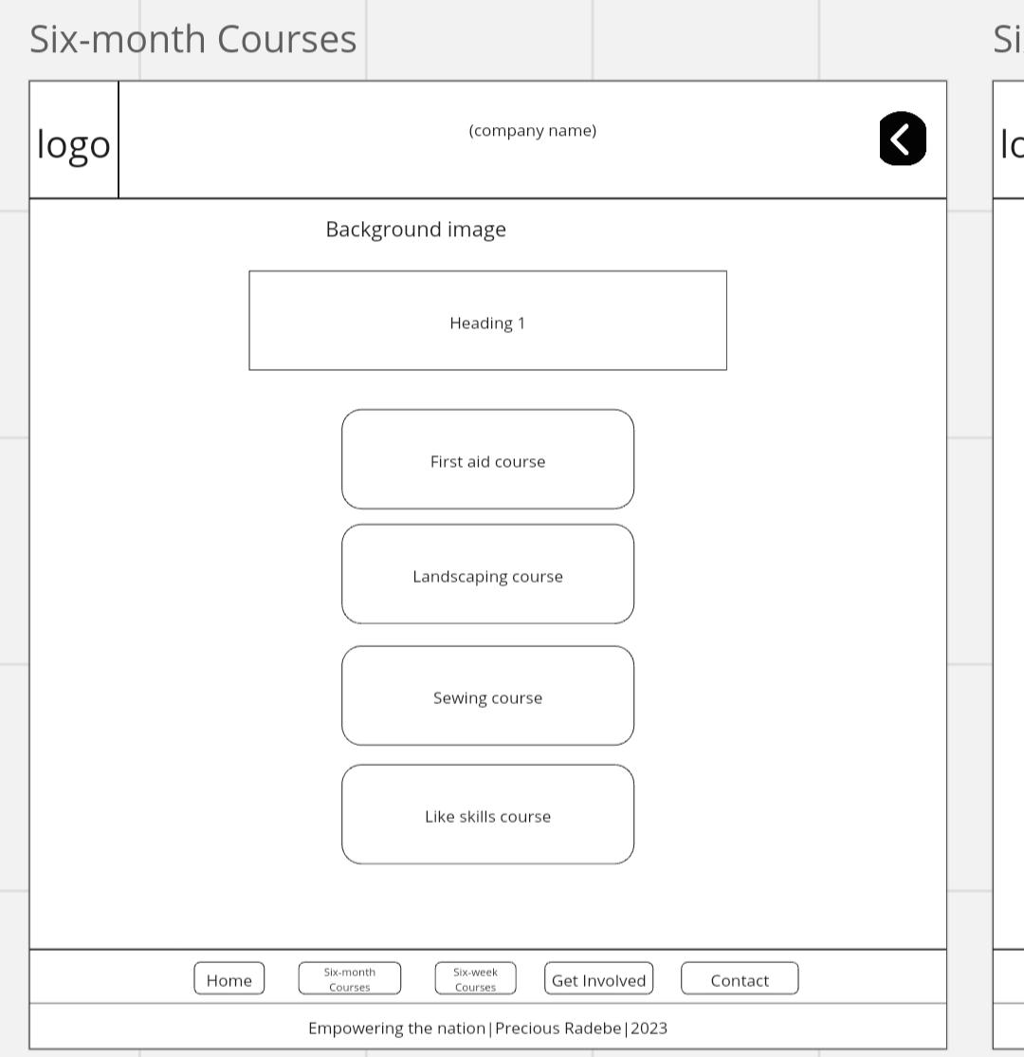

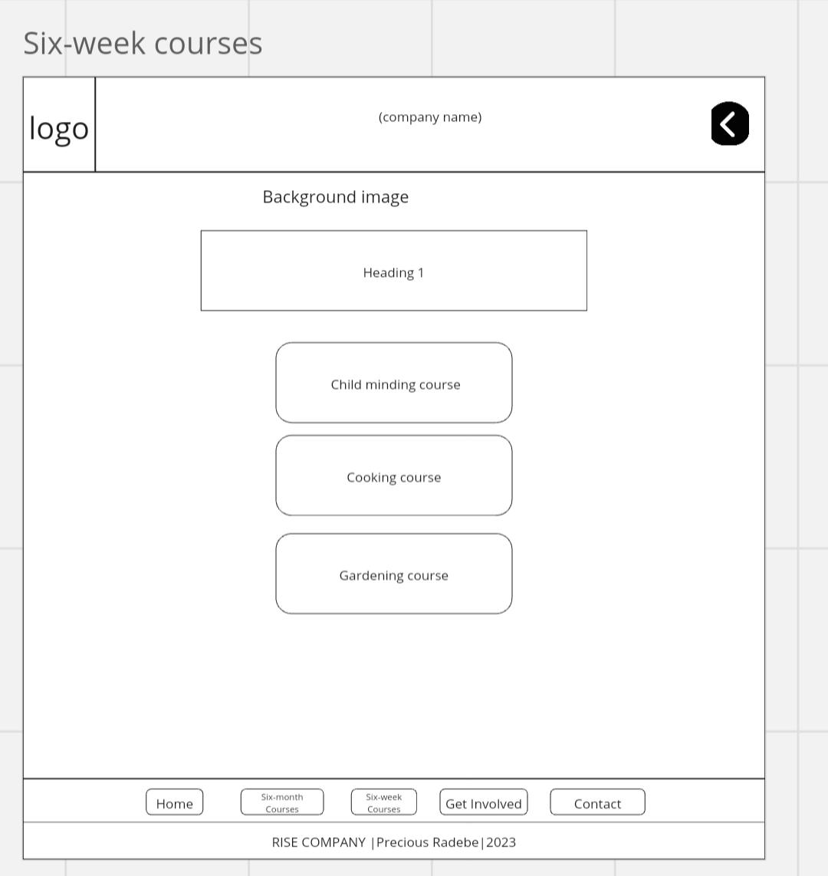

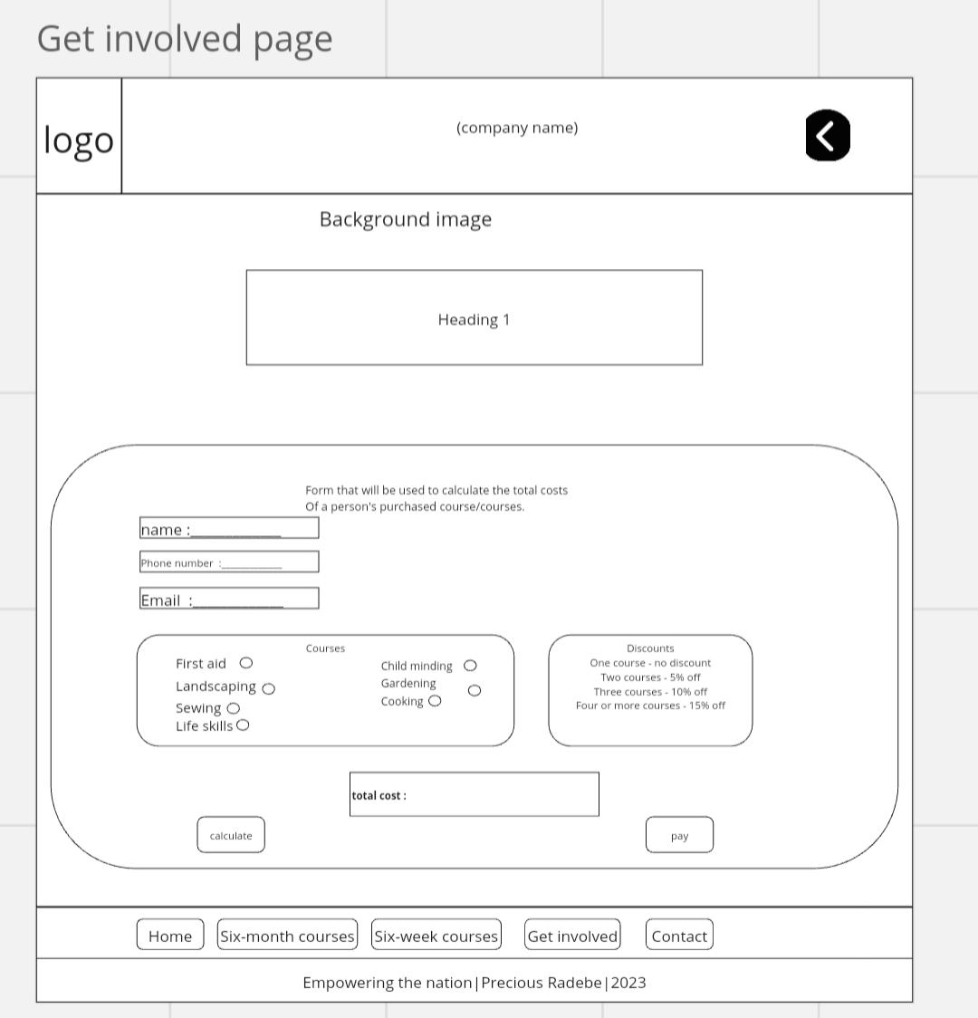

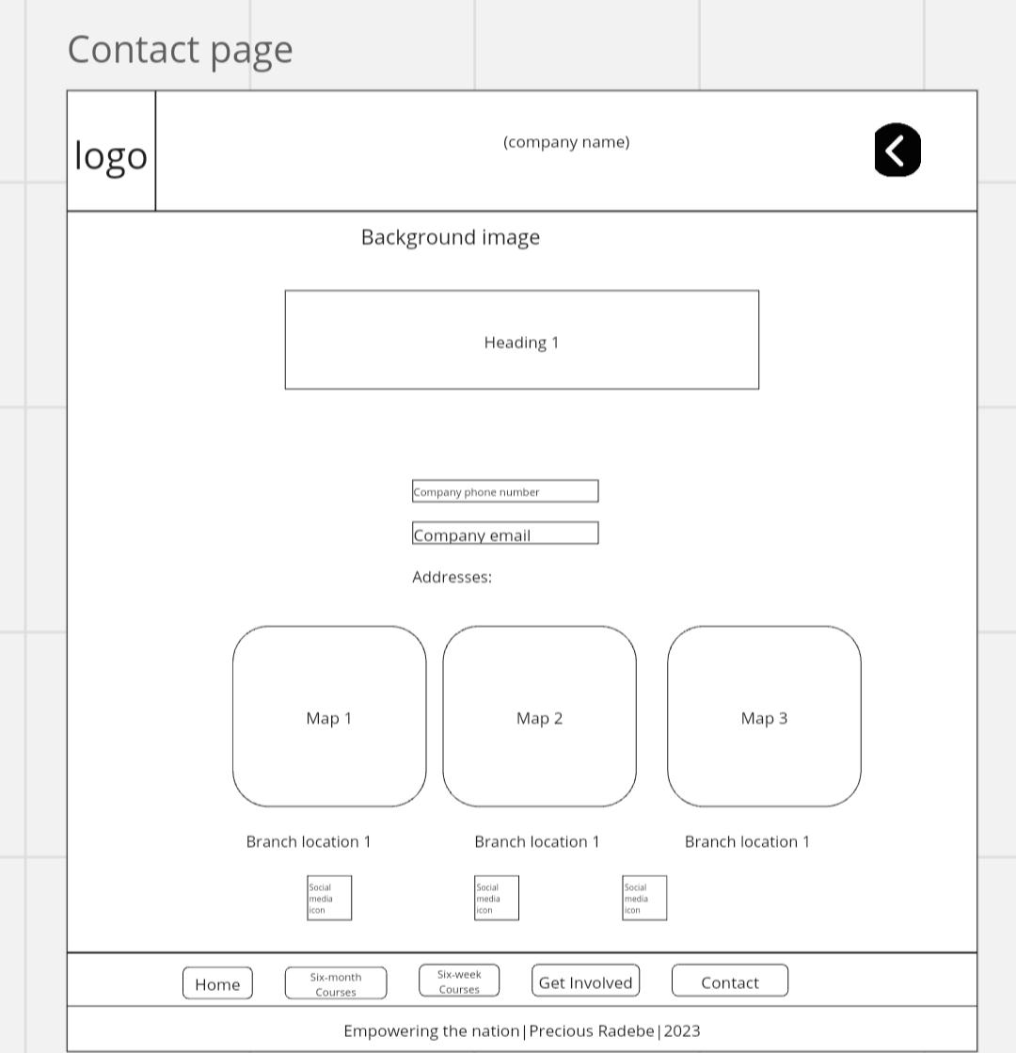

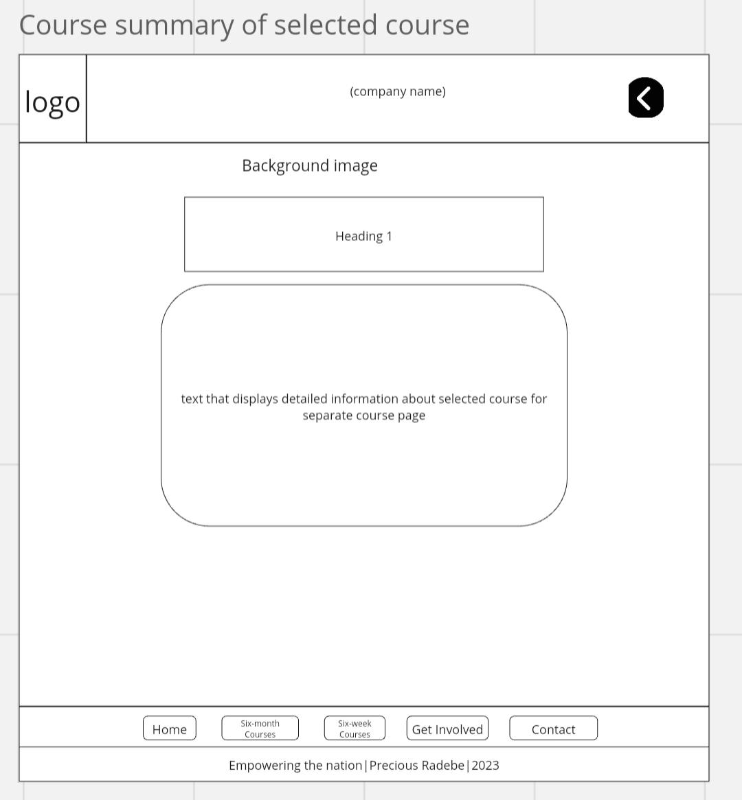

Logo design for Rise(our company)


Logo design for Empowering the nation



User-centred design
In our design methodology, our foremost focus lies on enhancing user experience and ensuring accessibility for all users. Our approach to design places a high value on creating an interface that is user-friendly and straightforward. This design philosophy is geared towards enabling users across both web and mobile platforms to effortlessly navigate and leverage the full range of capabilities that our platform offers. Through the integration of a clean and uncomplicated interface, individuals accessing our platform through various devices will find it intuitive to explore and utilize its features. To facilitate a smooth and coherent user journey, we incorporate easily recognizable symbols and meticulously crafted menu items, which act as navigational signposts guiding users to their intended destinations. This meticulous attention to detail leads to the cultivation of a more cohesive and fluid user experience, ultimately resulting in heightened satisfaction and engagement.

Reference list
Website and mobile app wireframes.29 December 2016. Miro-online whiteboard(version 3.25.7)[Mobile app]. [Accessed 27 August 2023].
Logo for our company sourced at: https://www.freelogodesign.org/logomaker-app/en/editor?section=&menu=
Logo for Empowering the nation sourced at: https://www.freelogodesign.org/logomaker-app/en/editor?section=&menu=

